**Create a Free VM In Azure**

Step 1 : Log In to the Azure Portal with registered email ID.

Step 2 : Search in Azure portal for ‘Free Services’ in the search bar. We can see the free services available in our free account.

Step 3: We can see the option to create Windows VM or Linux VM. Select ‘Create’ option under the Linux Virtual Machine section in order to create a Linux VM

Step 4 : Now, fill out the details as per our requirement.

* Enter the name of the virtual machine in the Virtual Machine text box
* Select the Geographical region
* Select the Image of the Linux Operation system. I selected Debian
* Select the available size in Linux VM (I selected Standard _B1s)
* Select the authentication type as per our choice. Select Authentication type as Password and enter the Username and Password of the administrative account.
* Select the allowed ports . HTTP (80), HTTPS (443), SSH (22)
* Add tags if we have the requirement

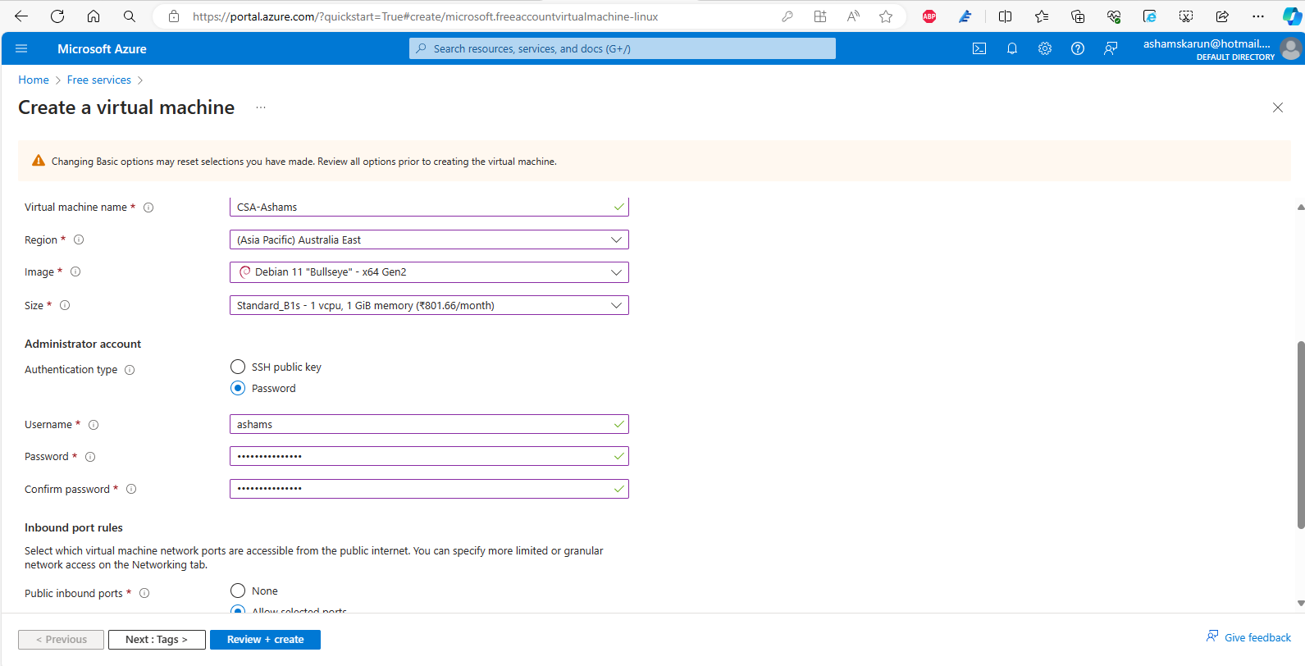

Step 5 : Click on the ‘Review + Create’ button, then click on the create to start the deployment.

Step 6 : Once the deployment is completed, navigate to Virtual Machine section in the newly created Virtual machine in order to connect the virtual machine to local machine.

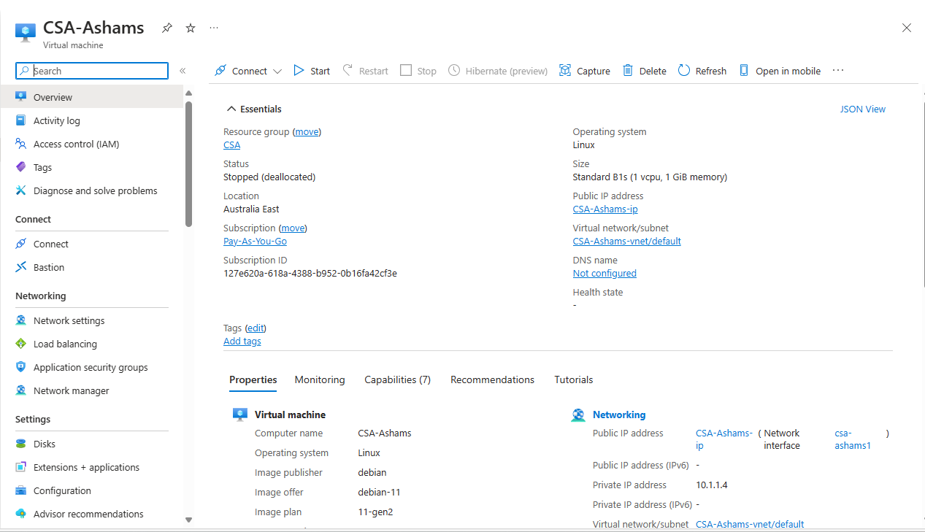

Public IP Address : 13.70.66.9

**Pinging Linux VM from Kali Linux**

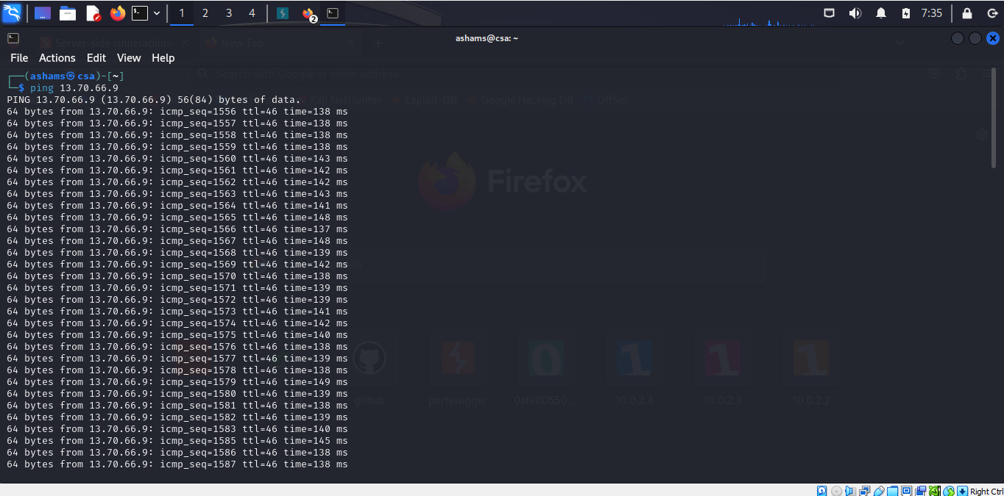

**Linux VM**

